Sri Lanka Institute of Advanced Technological Education
HNDIT 2 Year
Enterprise Architecture
Java Servlet Lab Sheet: 01
Task 01:
Create new web project using NetBeans and a servlet Page: helloServlet
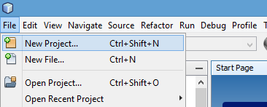
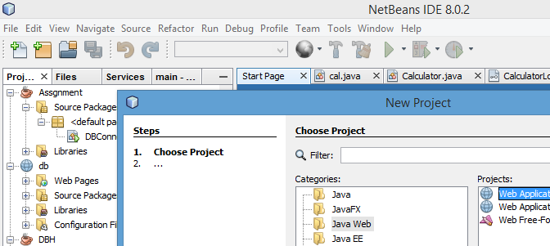

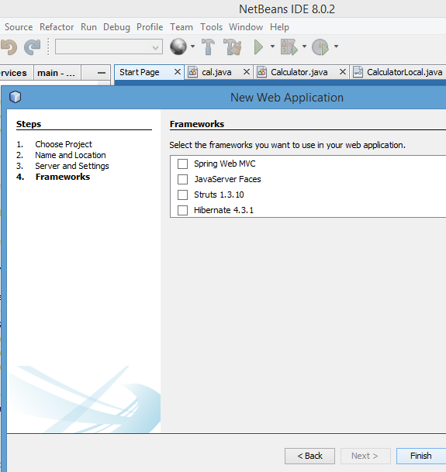
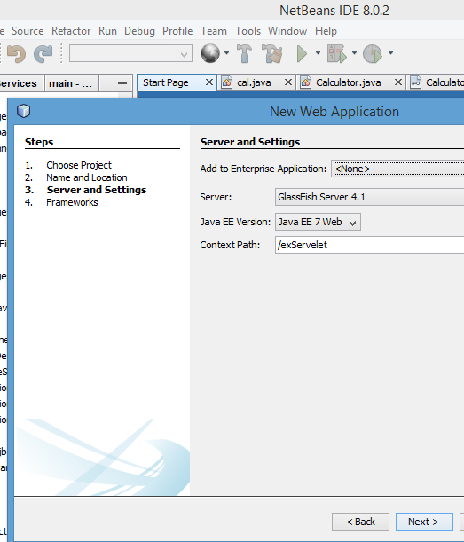
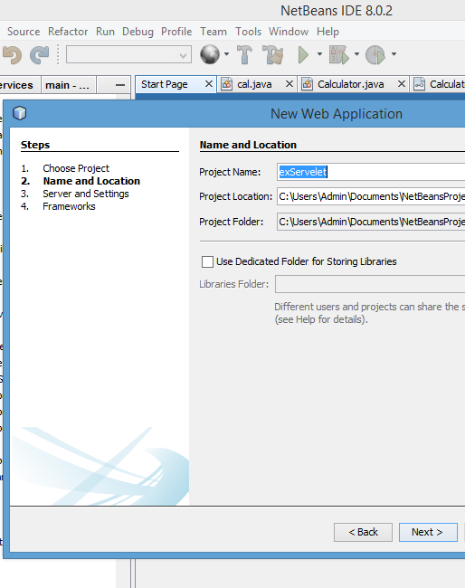

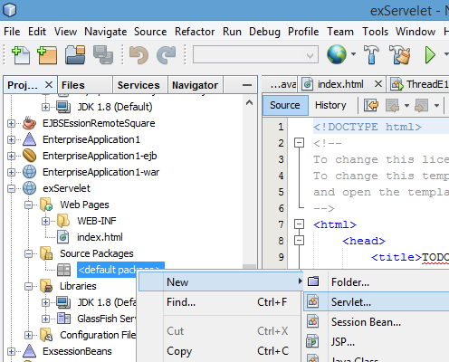
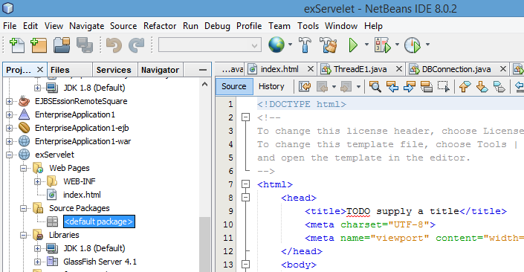

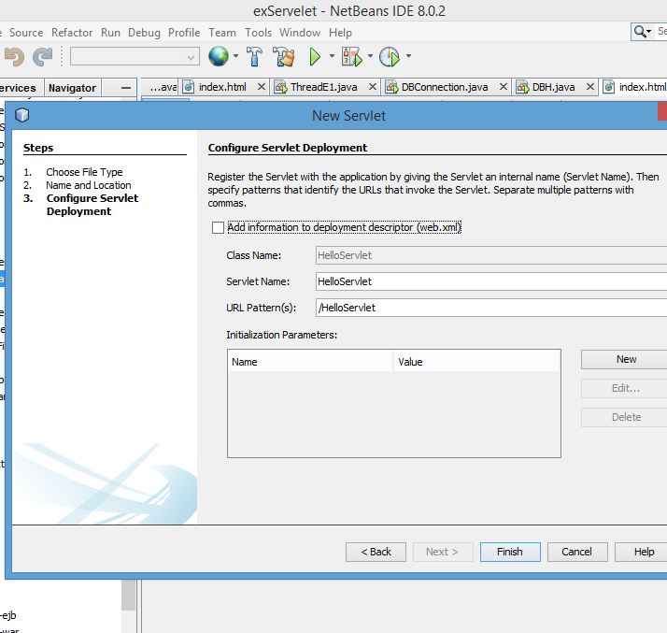
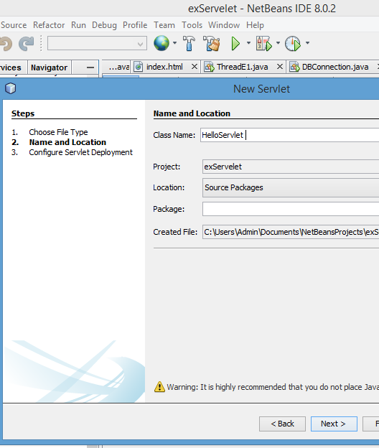

Task 02: Run the project and see the output.
Task 03: add form to index.html page. That form include Show message button only. Edit action attribute to display the helloServlet page
Task 04:
Modify the form by including two text boxes for get user input for First Name and Last Name
Modify helloServlet page to get the above two parameters and display full name
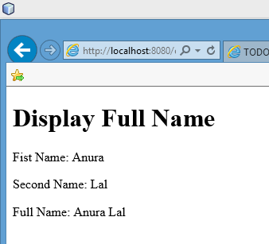
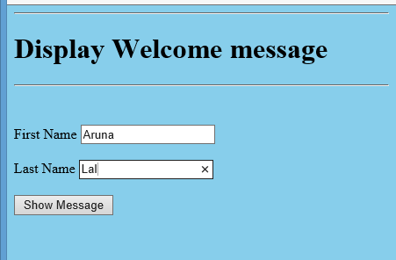
Hint use following codes:
String FN = request.getParameter("Ln");
out.println("<p>Second Name: " + LN + "</p>");
String LN = request.getParameter("Ln");
out.println("<p>Second Name: " + LN + "</p>");
out.println("<p>Full Name: " + FN +" "+LN+ "</p>");
out.println("</body>");
Task 05: modify code to display value is empty if user is not enter the data into text box

